Overloaded Inbox Scenario in Outlook

“Back from Leave: Prioritize What Matters”
Exercise Overview
In this exercise, you will step into the role of a Regional Financial Director at Northwestern Mutual returning from five days of leave to a full inbox.
Your goal is to use Microsoft 365 Copilot in Outlook to quickly:
- Summarize incoming emails
- Identify urgent matters and deadlines
- Prioritize high-impact responses
- Draft professional client and internal emails
- Schedule meetings with clear agendas
- Set reminders and follow-ups
Rather than manually reading every message, you will leverage Copilot to streamline decision-making, reduce email overload, and focus on what truly requires your attention.
By the end of this exercise, you will understand how Copilot can transform inbox management from a reactive task into a structured, strategic workflow.
Learning Objectives
By the end of this exercise, participants will be able to:
- Summarize multiple emails quickly
- Identify urgent and high-impact items
- Detect deadlines and risks
- Draft professional responses
- Use coaching to refine tone
- Schedule meetings with context
- Create follow-ups and reminders
Scenario Context
You are a Regional Financial Director at Northwestern Mutual. You are returning after 5 days of leave.
Your inbox contains:
- Client review requests
- A compliance clarification email
- A marketing campaign update
- An internal performance report
- A message from your manager about quarterly targets
You need to:
- Understand what happened
- Identify urgent items
- Respond professionally
- Schedule necessary follow-ups
- Regain control quickly

- Open your outlook using the following link and connect with your professional account: https://outlook.office.com/mail/
- Click on the Copilot icon on the top right to see some suggestions of prompts that you can use.
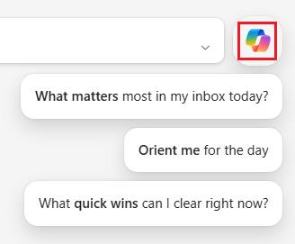
- Use the following prompt
Prompt 1: “What matter most in my inbox today?”
- Verify the message you got from your copilot which should look as follows.
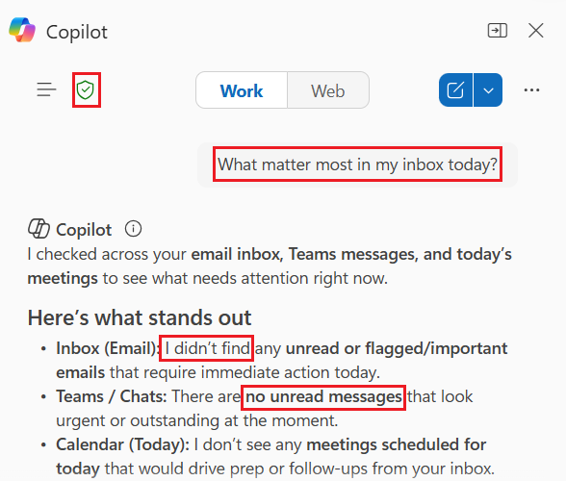
- Use the following Prompt to Copilot:
Prompt 2: “Identify urgent and high-impact emails in my inbox, including read ones”
- Observe the output
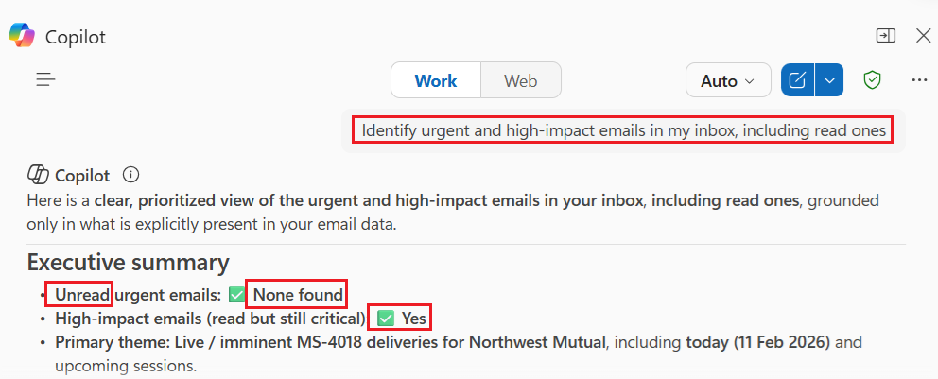
The output represent a written summary highlighting:
- No urgent unread emails; critical messages have been read and relate to MS-4018 deliveries for Northwest Mutual.
- Today's session confirmed; logistical details provided, no action needed.
- Customer thread and Teams link; guidance and access details available for reference.
- You are prepared and visible; stakeholder confidence reinforced.
- Upcoming session noted for Feb 19, 2026; confirmation required.
- No emails require a reply today; inbox is context-rich but operationally quiet.
- Use the following prompt to generate visuals instead of written text
Prompt 2: “Are there any upcoming deadlines I should be aware of?”
- Observe the output generated
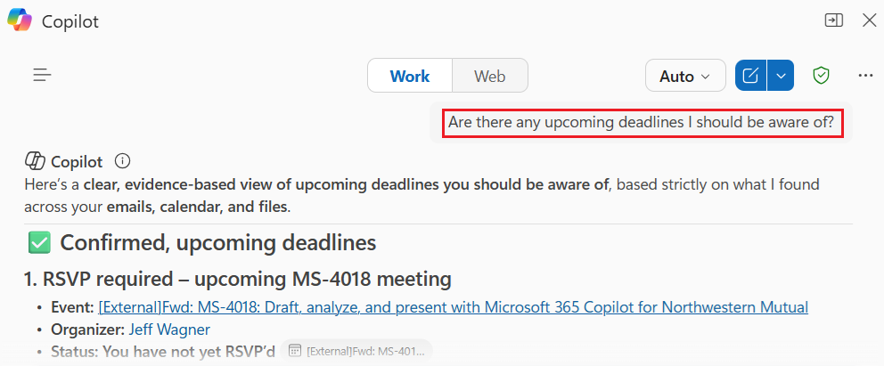
- Use the following prompt for more detailed and structured result
Prompt 3: “Summarize all emails from the past 5 days. Highlight key topics, action items, and any urgent matters.”
- Observe the final result obtained
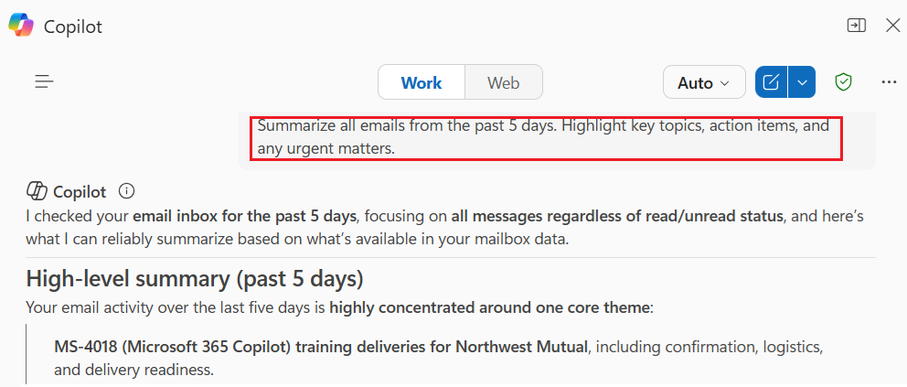
- Use the following prompt:
Prompt 4: “Analyze my inbox and prioritize emails based on urgency, deadlines, client impact, and compliance risk. Provide a ranked list with reasoning.”
- Observe the final output
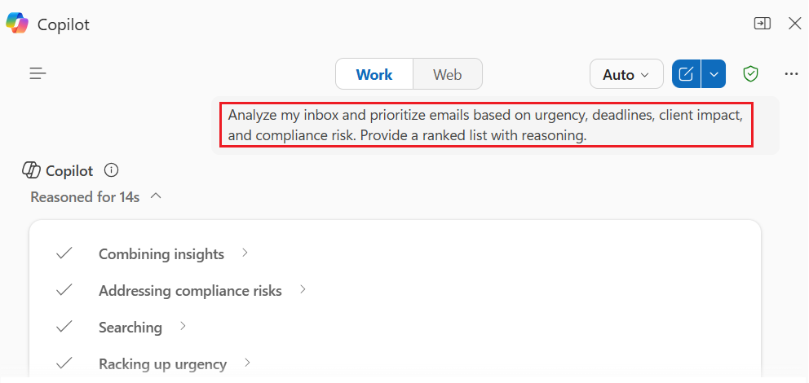
- Use the following prompt to get the list of today’s meeting in the outlook calendar
Prompt 5: “Provide a list of all meetings scheduled in my Outlook calendar for today, including time, duration, participants, and meeting subject”
- Review the results
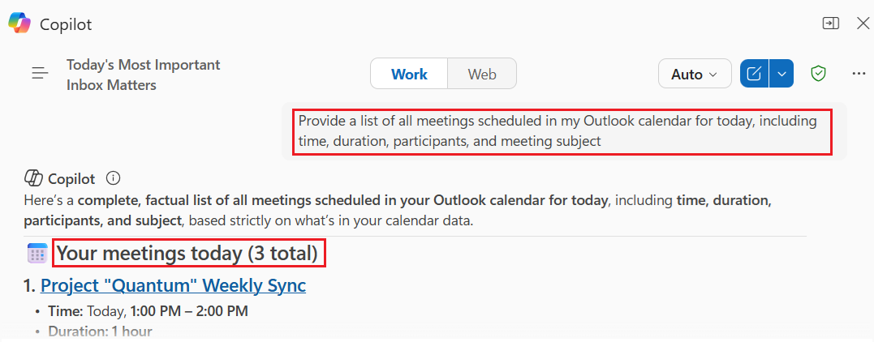
- Use the following prompt to get the meetings for the whole week:
Prompt 6: “Provide a list of all meetings scheduled in my Outlook calendar for this week, including time, duration, participants, and meeting subject”
- You have the following results
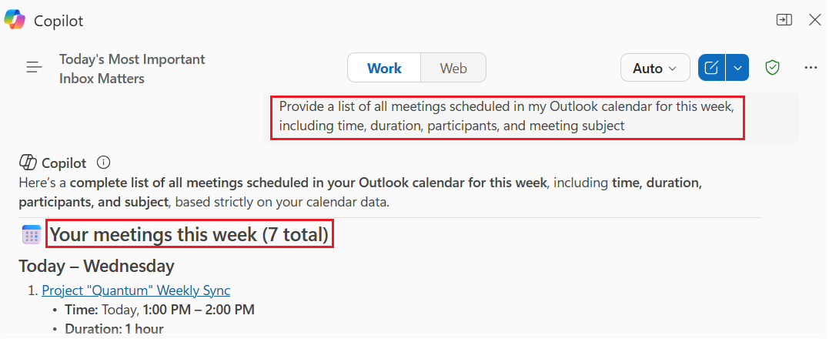
- Use the following prompt to organize the meetings by day
Prompt 7: “List all meetings scheduled in my Outlook calendar for this week, grouped by day. Provide the result as a table.”
- Observe the final result.
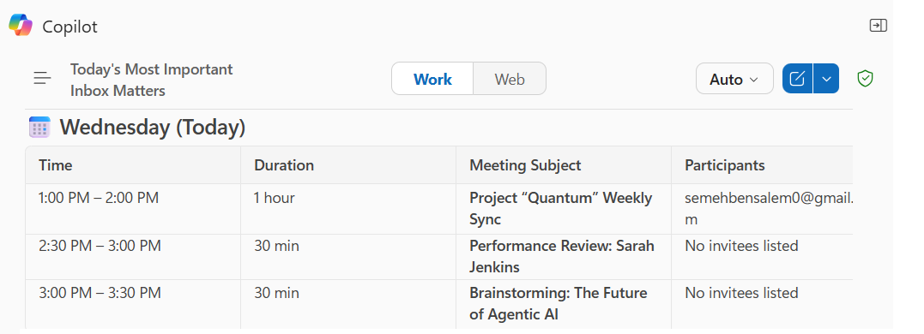
- Use this prompt
Prompt 8: “List the meetings scheduled for this week related to the Quantum project including past and future meetings.”
- Observe the final output
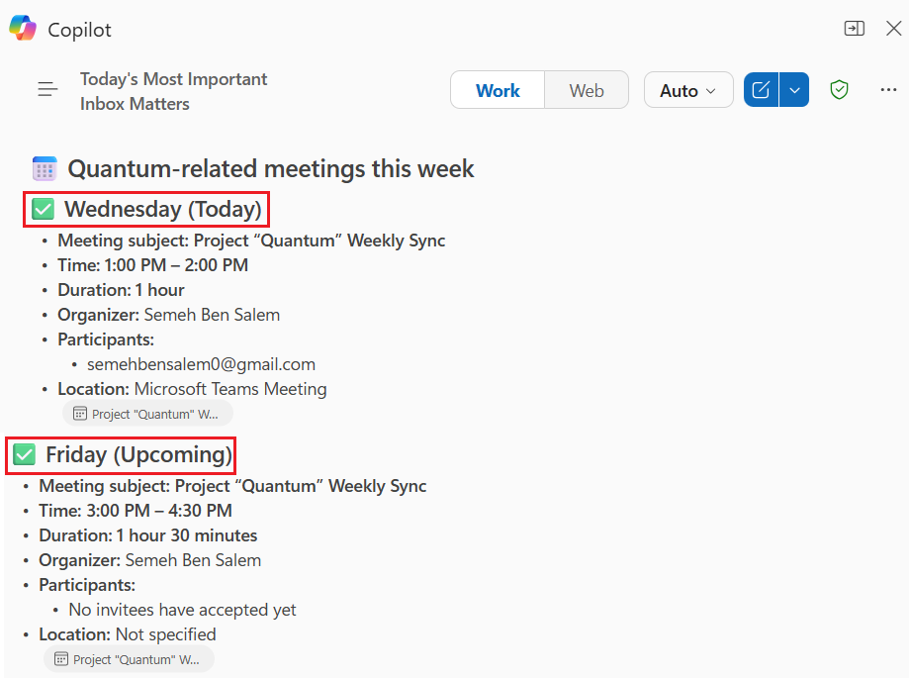
- Use this prompt:
Prompt 9: “List the meetings where Sam Chen is participating.”
- Observe the result
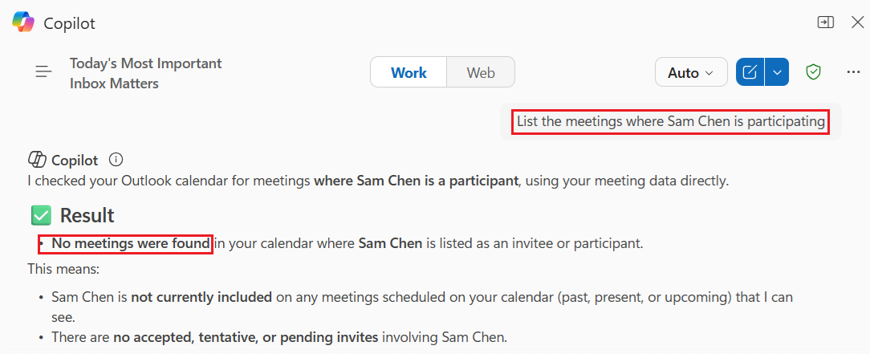
- Add Sam Chen to the list of participants of one of the meetings.
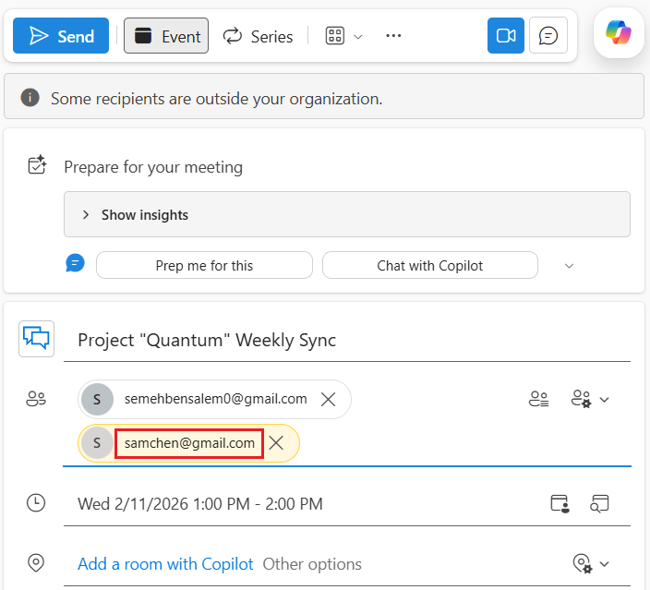
- Use a different name in the prompt to check if no results is obtained
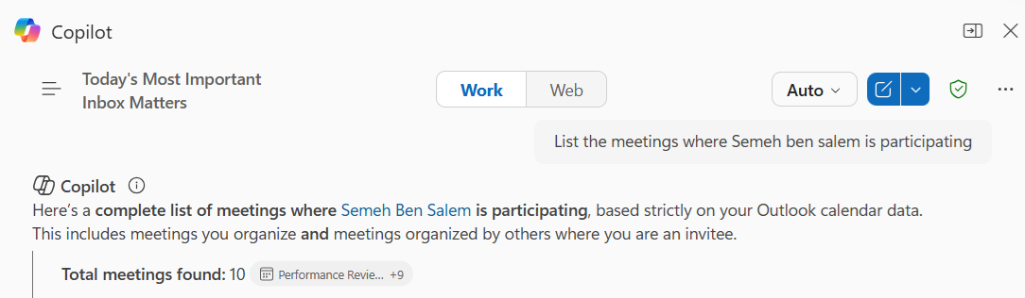
- Use this prompt
Prompt 10: “Retrieve all items related to the MS-4018 email thread, including emails, attachments, meeting invitations, and follow-up actions. Provide a structured summary including key decisions, open questions, deadlines, and next steps.”
- Select New email to write a new message in Outlook
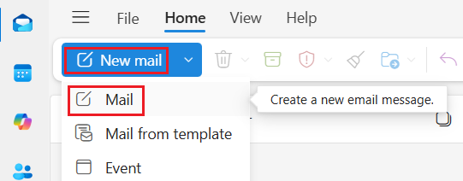
- You can also ask copilot to write a draft for you to send:
Prompt 11: “Draft a professional email reply within the MS4018 thread to confirm the scheduled training session dates and my participation. Mention that I am available and fully prepared for the sessions. Thank the organizers for the coordination. Use a clear, confident, and professional tone.”
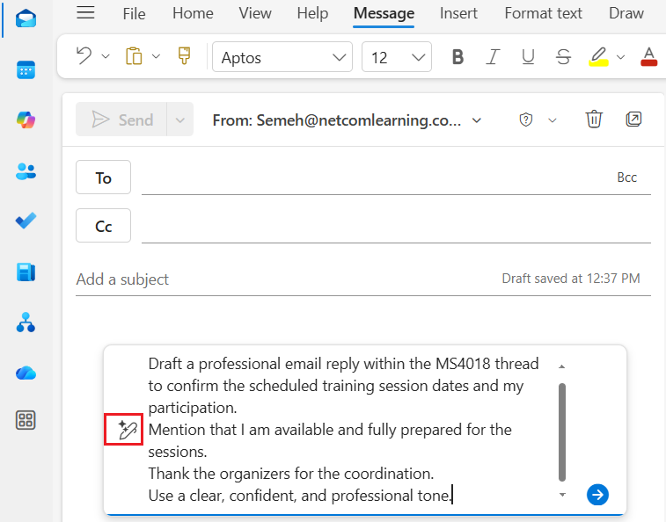
- Ask Copilot to enhance your email by selecting the Auto rewrite option. It's still short, so use the Suggested prompts and ask Copilot to Make it longer.
- Select Keep it to include the suggested text as your email.
- Review the email and make any necessary adjustments.
- Add the recipients (your team members) and send the email.
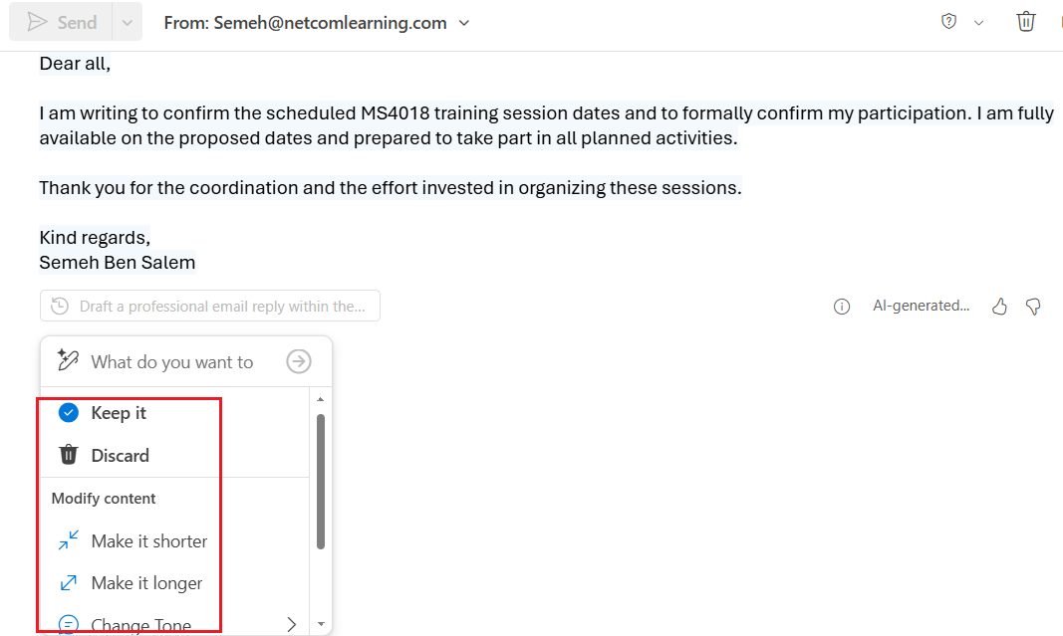
- Open the email thread you sent.
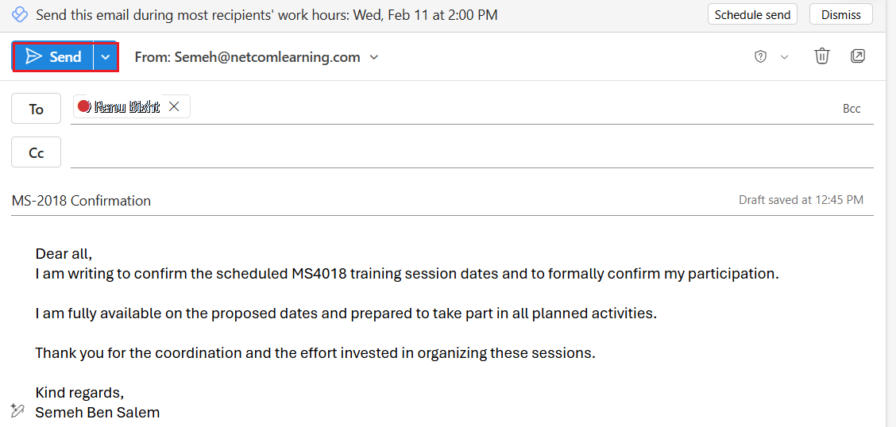
- Select the Copilot icon from the Home ribbon to open the Copilot pane.
- Ask copilot to get information about the sender and participants using the following prompt:
Prompt 12: “Analyze this email and list all participants involved in this conversation. Include the sender, recipients (To), CC, and any other visible participants. For each person, indicate their Email address, role in the organization, role in the thread and summarize their level of involvement.”
- Ask Copilot to suggest the best time for the meeting by entering the following prompt
Prompt 13: “Schedule a meeting for next week with all participants in this email thread. Check attendees’ availability and propose the best available time slot. Include a clear meeting subject and a brief agenda based on the context of this conversation.”.
Copilot searches the calendars of your email recipients, and suggests a time based on their availability.
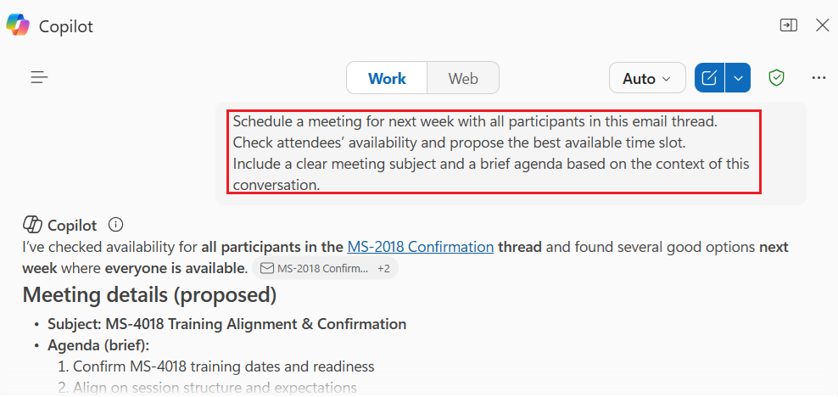
- Review the suggested time.
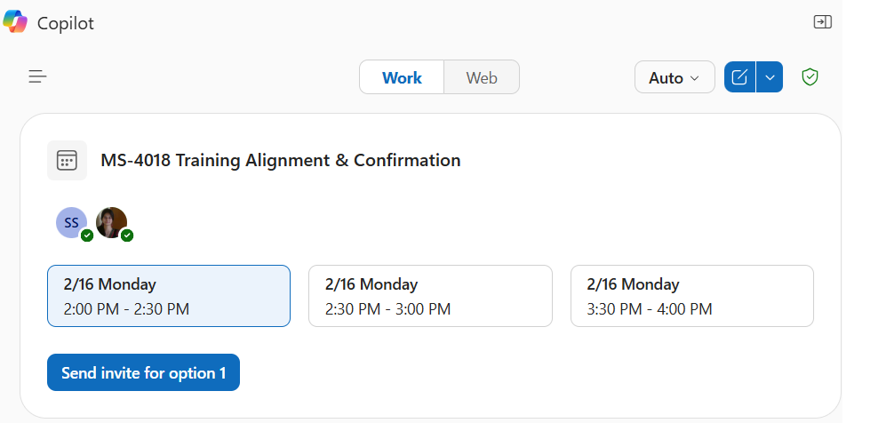
- Select one of the suggested times for the meeting
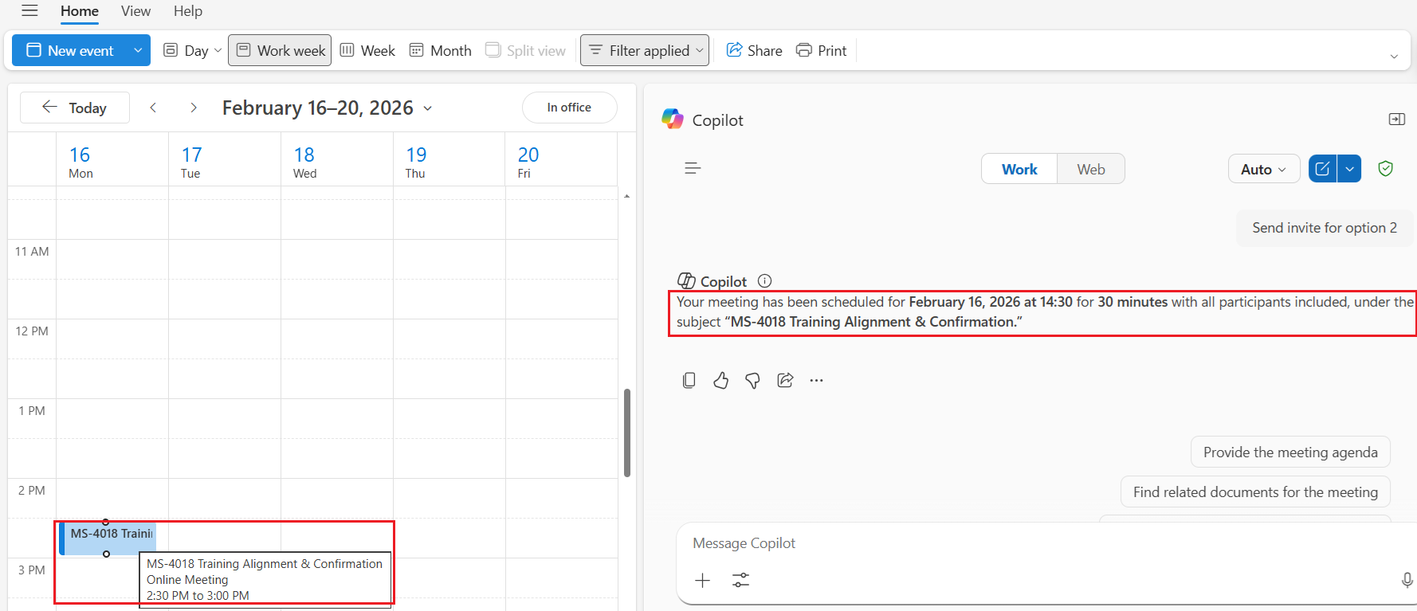
- The invitation was sent by copilot
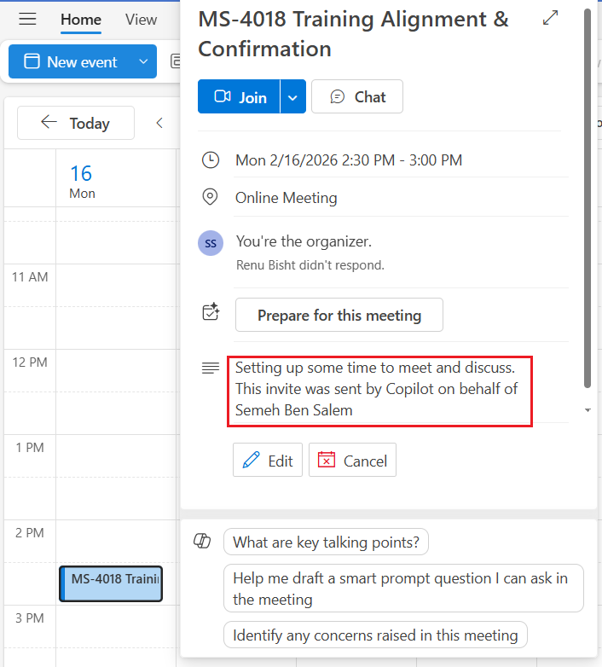
- You can also use the suggestions provided when editing the invitation
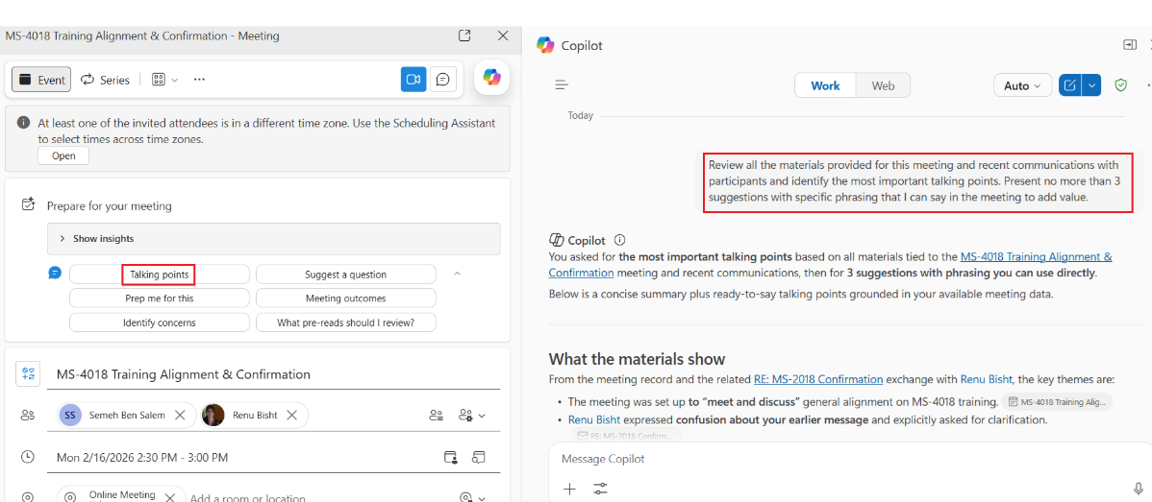
- Use the following prompt to generate the agenda for the meeting:
Prompt 14: “Based on the context of this meeting and the related email thread, generate a structured meeting agenda. Include a clear objective, key discussion topics, time allocation for each item, and expected outcomes.”
- Use the following prompt to generate a complete meeting
Prompt 15: “Analyze this email thread and schedule a 60-minute follow-up meeting with all relevant participants.
Select the earliest available time slot next week based on my calendar and attendees’ availability.
Create the meeting and add it directly to my Outlook calendar.
Include the following directly in the meeting invitation body:
- A clear and professional meeting title
- Meeting objective
- Structured agenda with time allocation
- Key discussion points
- Decision items
- Expected outcomes
- Relevant context summarized from the email thread
- Any identified risks or pending questions
Add a Microsoft Teams meeting link and ensure the invitation is ready to send.“

